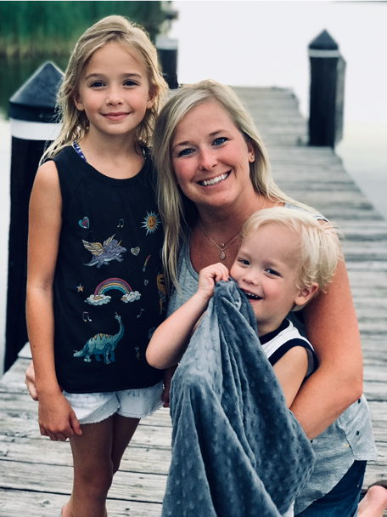

**favorites**

University of Memphis

Chocolate Covered Fruit

Reese’s Pieces/Peanut M&M’s

Muddy Buddies Chex Mix

Cajun Trail Mix

Bai Coconut Water

½ Half and Half½ Tea

Rock N Roll Sushi

Mexican

Lenny’s

Buff City Soap

Mani & Pedi

Marshalls

TJMaxx

Target

Amazon

**Welcome from Mrs. Beard**

My name is Caroline Beard. I have been with my high school sweetheart for 19 years. We have two children and a dog named Charlie. Bailee and Easton are both attending Arlington Schools this year! Bailee is in 6th grade, and Easton is in PreK. GO TIGERS GO!! I enjoy spending time with my family & friends, watching movies, traveling, attending sporting events, and eating out.

**education and experience**

I attended Altruria Elementary K-5, Elmore Park Middle 6-8, Bartlett High School 9-12, and received a Bachelor’s Degree in Early Childhood Education from the University of Memphis.

I am in my 11th year of teaching.

This my 11th year at AES.

This is my 4th year in 2nd grade. I taught one year in Kindergarten and 6 years in 1stgrade.

**Birthday** May 3rd

**contact**

[caroline.beard@acsk-12.org](mailto:caroline.beard@acsk-12.org)

901-867-6000

MEET **the**

TEACHER