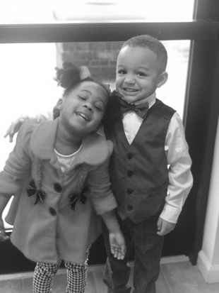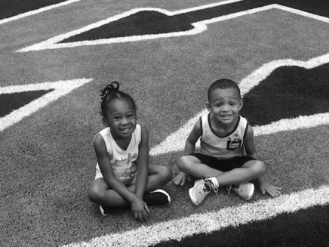

MEET **the**

TEACHER



**Welcome from Ms. Freeman**

My name is Terri Freeman. I have two children, an athletic handsome 5 year old and a sassy beautiful 3 year old. I enjoy spending time with my family & friends, watching movies, traveling, going to and watching basketball and football games, and eating out.



**education and experience**

I attended :

Mt. Pisgah K-1, Germantown Elementary 2-4

Germantown Middle 5-6, Appling Middle 7-8

Bartlett High 9-12. I earned a Bachelor’s Degree from Tennessee State University, Master’s Degree in Educational Leadership from Trevecca Nazarene,

ED.S in Curriculum and Instruction from Liberty University

I am in my 15th year of teaching.

9 years in 1st grade

This my 6th year in 2nd grade.

**Birthday -December 7th**

**contact**

terrisita.freeman[@acsk-12.org](mailto:stephanie.goodman@acsk-12.org)

901-867-6000

**favorites**

U of Memphis/ Lakers/Grizzlies Basketball

Reese Pieces /Peanut M&M’s

Sour Cream N’ Onion Pringles

Peach Sweet Tea

Diet Ginger Ale and Lemonade

Chick-Fil-A

Target

Amazon

Nike

Old Navy

Redlands

Outback

TJMaxx

Marshalls

Buff City

Mani and Pedi