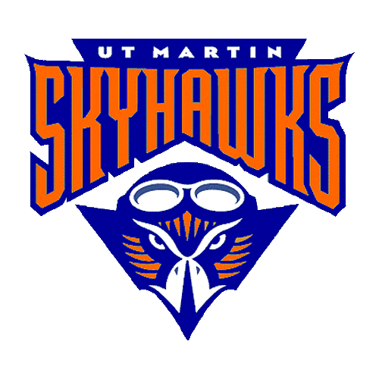

**Birthday**

**April 14**

**Education and Experience**

I received a Bachelor’s Degree in Elementary Education from the University of Memphis as well as a Master’s Degree in Administration and Supervision.

I am in my 26th year of teaching.

This my 14th year at AES.

**contact**

[monica.gallimore@acsk-12.org](mailto:monica.gallimore@acsk-12.org)

901-867-6000

**Favorites**

McAllister’s

Pyro’s

Olive Garden

Sonic

McDonald’s

Steinmart

Kirkland’s

Pringles

Butterfingers

Cinnamon Gum

Unsweet tea

Crosses

**Welcome from Mrs. Gallimore**

My name is Monica Gallimore. I have been married to my husband, Kevin, for 25 years. We have two children. Griffin is a sophomore at UT Martin, and Kaity is a senior at AHS. We also have 2 dogs and a cat. I love animals! I enjoy spending time with family and friends, as well as reading, watching movies, playing tennis, and eating out.

MEET **the**

TEACHER